МІНІСТЕРСТВО ОСВІТИ І НАУКИ УКРАЇНИ

НАЦІОНАЛЬНИЙ УНІВЕРСИТЕТ “ЛЬВІВСЬКА ПОЛІТЕХНІКА”

ІНСТИТУТ КОМП’ЮТЕРНИХ НАУК ТА ІНФОРМАЦІЙНИХ ТЕХНОЛОГІЙ

кафедра систем штучного інтелекту



**ЗВІТ**

про виконання лабораторної роботи №1

з курсу «Проектування систем глибинного навчання»

на тему «ПрогнозуваннянаосновіRNN LSTM GRU»

Виконав:

*ст. групи КНСШ-12*

*Карпінський Р.М*

Перевірив:

*Пелешко Д.Д*

ЛЬВІВ – 2021

**Мета:** Виконати задані завдання за темою ПрогнозуваннянаосновіRNN LSTM GRU.

**Завдання**

* Вивчити структуру LSTM та GRU та принцип побудови мережі за допомогоюKeras.
* Розібратися з Case1 – прогнозування сигналів. Згенерувати свій сигналнабазі sinта cos, та їх комбінації і спробувати спрогнозувати, оцінити точність.
* Розібрати з задачею прогнозування часових рядів фінансової природизадопомогою LSTM та GRU.
* Досягти кращої точності ніж наведено в прикладі, за рахунок переналаштуваннямережі.

**Виконання роботи:**

import numpy as np

import pandas as pd

import math

import sklearn

import sklearn.preprocessing

import datetime

import os

import matplotlib.pyplot as plt

%tensorflow_version 1.x

import tensorflow as tf

from keras.layers.recurrent import LSTM

from keras.models import Sequential

from keras.layers import Dense, Dropout

dataset = pd.read_csv('Sin Wave Data Generator.csv')

dataset.head(5)

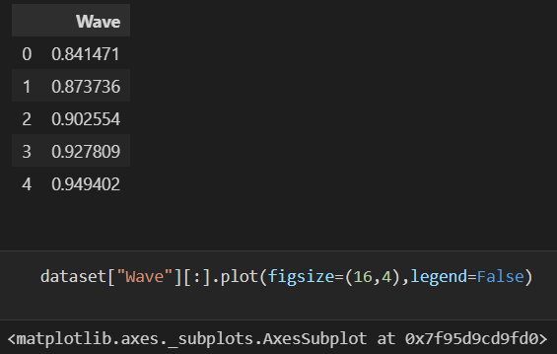

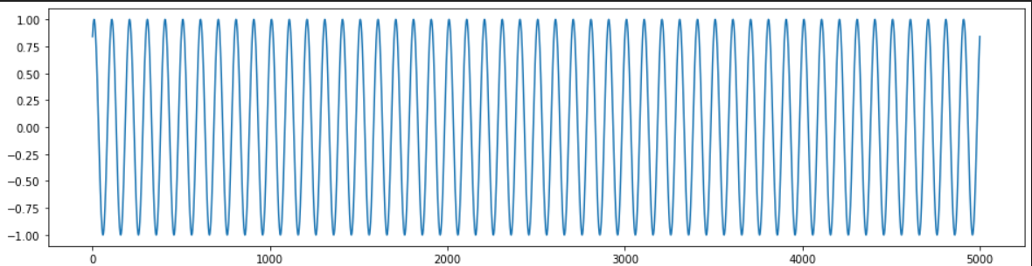

def normalise_windows(window_data):

    # A support function to normalize a dataset

    normalised_data = []

    for window in window_data:

        normalised_window = [((float(p) / float(window[0])) - 1) for p in window]

        normalised_data.append(normalised_window)

    return normalised_data

def load_data(dataset, column, seq_len, normalise_window):

    # A support function to help prepare datasets for an RNN/LSTM/GRU

    data = dataset.loc[:,column]

    sequence_length = seq_len + 1

    result = []

    for index in range(len(data) - sequence_length):

        result.append(data[index: index + sequence_length])

    if normalise_window:

        result = normalise_windows(result)

    result = np.array(result)

    #Last 10% is used for validation test, first 90% for training

    row = round(0.9 * result.shape[0])

    train = result[:int(row), :]

    np.random.shuffle(train)

    x_train = train[:, :-1]

    y_train = train[:, -1]

    x_test = result[int(row):, :-1]

    y_test = result[int(row):, -1]

    x_train = np.reshape(x_train, (x_train.shape[0], x_train.shape[1], 1))

    x_test = np.reshape(x_test, (x_test.shape[0], x_test.shape[1], 1))

    return [x_train, y_train, x_test, y_test]

Enrol_window = 100

feature_train, label_train, feature_test, label_test = load_data(dataset, 'Wave', Enrol_window, False)

print ('Datasets generated')

model = Sequential()

model.add(LSTM(50, return_sequences=True, input_shape=(feature_train.shape[1],1)))

model.add(Dropout(0.2))

model.add(LSTM(100, return_sequences=False))

model.add(Dropout(0.2))

model.add(Dense(1, activation = "linear"))

model.compile(loss='mse', optimizer='adam')

print ('model compiled')

print (model.summary())

Total params: 70,901 Trainable params: 70,901 Non-trainable params: 0

model = Sequential()

model.add(LSTM(40, return_sequences=True, input_shape=(feature_train.shape[1],1)))

model.add(Dropout(0.2))

model.add(LSTM(70, return_sequences=False))

model.add(Dropout(0.2))

model.add(Dense(1, activation = "linear"))

model.compile(loss='mse', optimizer='adam')

print ('model compiled')

print (model.summary())

history_adv =  model.fit(feature_train, label_train, batch_size=256, epochs=10, validation_data = (feature_test, label_test))

val_loss = history.history['val_loss']

val_loss_adv = history_adv.history['val_loss']

val_loss = val_loss[1:]

val_loss_adv = val_loss_adv[1:]

epochs_range = range(9)

plt.figure(figsize=(10,10))

plt.plot(epochs_range, val_loss, label='Втрати на валідації базової моделі')

plt.plot(epochs_range, val_loss_adv, label='Втрати на валідації покращеної моделі')

plt.legend(loc='upper right')

plt.title(f'Графіки втрат покращеної моделі')

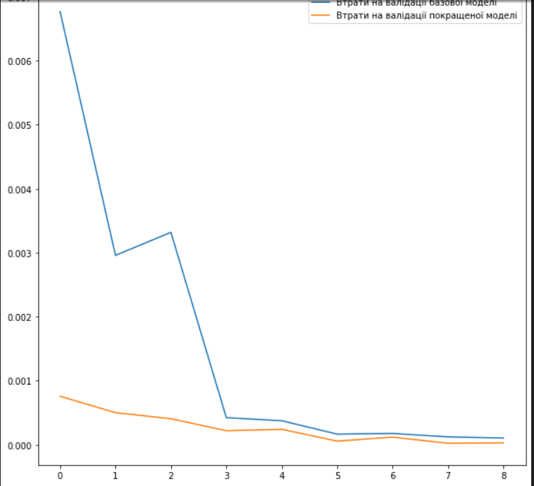

from numpy import newaxis

def predict_sequence_full(model, data, window_size):

    #Shift the window by 1 new prediction each time, re-run predictions on new window

    curr_frame = data[0]

    predicted = []

    for i in range(len(data)):

        predicted.append(model.predict(curr_frame[newaxis,:,:])[0,0])

        curr_frame = curr_frame[1:]

        curr_frame = np.insert(curr_frame, [window_size-1], predicted[-1], axis=0)

    return predicted

def plot_results(predicted_data, true_data):

    fig = plt.figure(facecolor='white')

    ax = fig.add_subplot(111)

    ax.plot(true_data, label='True Data')

    plt.plot(predicted_data, label='Prediction')

    plt.legend(loc='upper left')

    plt.show()

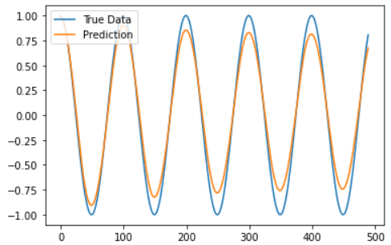

**\*\*Case 2. NY Stock Price Prediction RNN LSTM GRU\*\***

import numpy as np

import pandas as pd

from sklearn.preprocessing import MinMaxScaler

import matplotlib.pyplot as plt

# tensorflow 1

import tensorflow.compat.v1 as tf1

tf1.disable_v2_behavior()

# tensorflow 2

from tensorflow import keras

from tensorflow.keras import layers

# split data in 80%/10%/10% train/validation/test sets

valid_set_size_percentage = 10

test_set_size_percentage = 10

# split data in 80%/10%/10% train/validation/test sets

valid_set_size_percentage = 10

test_set_size_percentage = 10

#display parent directory and working directory

print(os.path.dirname(os.getcwd())+':', os.listdir(os.path.dirname(os.getcwd())))

print(os.getcwd()+':', os.listdir(os.getcwd()))

# import all stock prices

df = pd.read_csv("prices-split-adjusted.csv", index_col = 0)

df.info()

df.head()

# number of different stocks

print('\nnumber of different stocks: ', len(list(set(df.symbol))))

print(list(set(df.symbol))[:10])

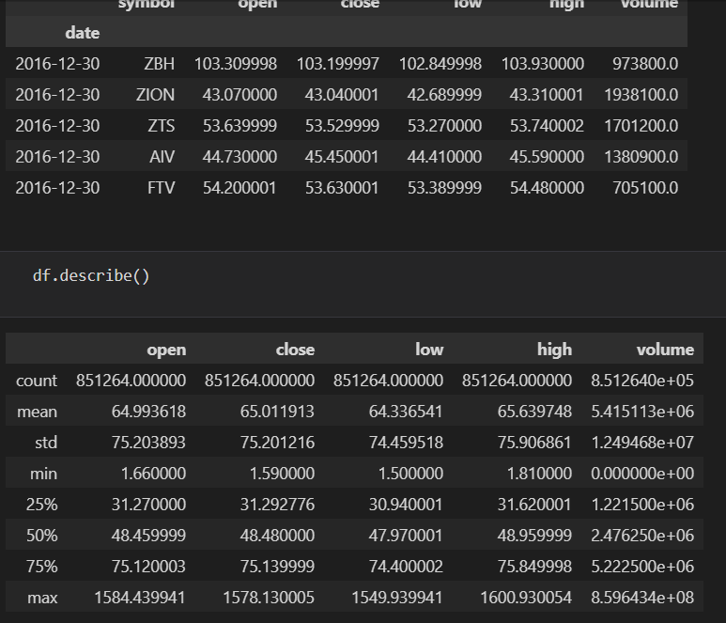

plt.figure(figsize=(15, 5));

plt.subplot(1,2,1);

plt.plot(df[df.symbol == 'EQIX'].open.values, color='red', label='open')

plt.plot(df[df.symbol == 'EQIX'].close.values, color='green', label='close')

plt.plot(df[df.symbol == 'EQIX'].low.values, color='blue', label='low')

plt.plot(df[df.symbol == 'EQIX'].high.values, color='black', label='high')

plt.title('stock price')

plt.xlabel('time [days]')

plt.ylabel('price')

plt.legend(loc='best')

#plt.show()

plt.subplot(1,2,2);

plt.plot(df[df.symbol == 'EQIX'].volume.values, color='black', label='volume')

plt.title('stock volume')

plt.xlabel('time [days]')

plt.ylabel('volume')

plt.legend(loc='best');

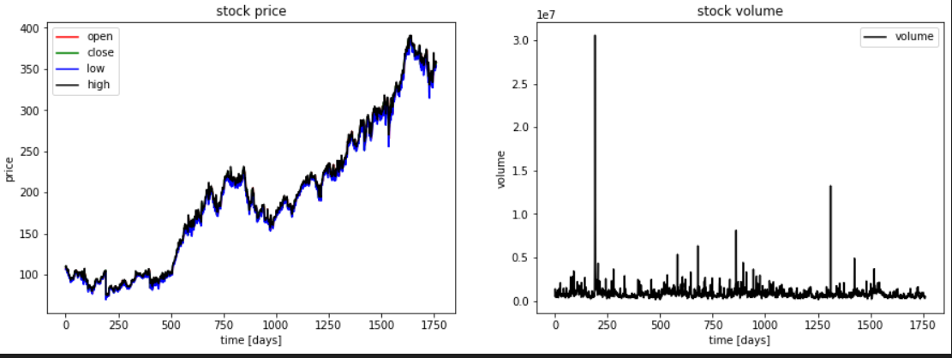

# function for min-max normalization of stock

def normalize_data(df):

    min_max_scaler = sklearn.preprocessing.MinMaxScaler()

    df['open'] = min_max_scaler.fit_transform(df.open.values.reshape(-1,1))

    df['high'] = min_max_scaler.fit_transform(df.high.values.reshape(-1,1))

    df['low'] = min_max_scaler.fit_transform(df.low.values.reshape(-1,1))

    df['close'] = min_max_scaler.fit_transform(df['close'].values.reshape(-1,1))

    return df

# function to create train, validation, test data given stock data and sequence length

def load_data(stock, seq_len):

    data_raw = stock.to_numpy() # convert to numpy array

    data = []

    # create all possible sequences of length seq_len

    for index in range(len(data_raw) - seq_len):

        data.append(data_raw[index: index + seq_len])

    data = np.array(data);

    valid_set_size = int(np.round(valid_set_size_percentage/100*data.shape[0]));

    test_set_size = int(np.round(test_set_size_percentage/100*data.shape[0]));

    train_set_size = data.shape[0] - (valid_set_size + test_set_size);

    x_train = data[:train_set_size,:-1,:]

    y_train = data[:train_set_size,-1,:]

    x_valid = data[train_set_size:train_set_size+valid_set_size,:-1,:]

    y_valid = data[train_set_size:train_set_size+valid_set_size,-1,:]

    x_test = data[train_set_size+valid_set_size:,:-1,:]

    y_test = data[train_set_size+valid_set_size:,-1,:]

    return [x_train, y_train, x_valid, y_valid, x_test, y_test]

# choose one stock

df_stock = df[df.symbol == 'EQIX'].copy()

df_stock.drop(['symbol'],1,inplace=True)

df_stock.drop(['volume'],1,inplace=True)

cols = list(df_stock.columns.values)

print('df_stock.columns.values = ', cols)

# normalize stock

df_stock_norm = df_stock.copy()

df_stock_norm = normalize_data(df_stock_norm)

# create train, test data

seq_len = 20 # choose sequence length

x_train, y_train, x_valid, y_valid, x_test, y_test = load_data(df_stock_norm, seq_len)

print('x_train.shape = ',x_train.shape)

print('y_train.shape = ', y_train.shape)

print('x_valid.shape = ',x_valid.shape)

print('y_valid.shape = ', y_valid.shape)

print('x_test.shape = ', x_test.shape)

print('y_test.shape = ',y_test.shape)

plt.figure(figsize=(15, 5))

plt.plot(df_stock.open.values, color='red', label='open')

plt.plot(df_stock.close.values, color='green', label='low')

plt.plot(df_stock.low.values, color='blue', label='low')

plt.plot(df_stock.high.values, color='black', label='high')

plt.title('stock')

plt.xlabel('time [days]')

plt.ylabel('normalized price/volume')

plt.legend(loc='best')

plt.show()

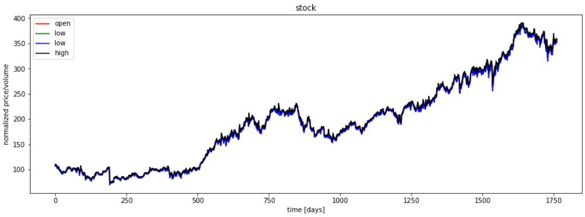

## Basic Cell RNN in tensorflow

index_in_epoch = 0;

perm_array  = np.arange(x_train.shape[0])

np.random.shuffle(perm_array)

# function to get the next batch

def get_next_batch(batch_size):

    global index_in_epoch, x_train, perm_array

    start = index_in_epoch

    index_in_epoch += batch_size

    if index_in_epoch > x_train.shape[0]:

        np.random.shuffle(perm_array) # shuffle permutation array

        start = 0 # start next epoch

        index_in_epoch = batch_size

    end = index_in_epoch

    return x_train[perm_array[start:end]], y_train[perm_array[start:end]]

# parameters

n_steps = seq_len-1

n_inputs = 4

n_neurons = 200

n_outputs = 4

n_layers = 2

learning_rate = 0.001

batch_size = 50

n_epochs = 100

train_set_size = x_train.shape[0]

test_set_size = x_test.shape[0]

tf.reset_default_graph()

X = tf.placeholder(tf.float32, [None, n_steps, n_inputs])

y = tf.placeholder(tf.float32, [None, n_outputs])

# use Basic RNN Cell

layers = [tf.contrib.rnn.BasicRNNCell(num_units=n_neurons, activation=tf.nn.elu)

          for layer in range(n_layers)]

multi_layer_cell = tf.contrib.rnn.MultiRNNCell(layers)

rnn_outputs, states = tf.nn.dynamic_rnn(multi_layer_cell, X, dtype=tf.float32)

stacked_rnn_outputs = tf.reshape(rnn_outputs, [-1, n_neurons])

stacked_outputs = tf.layers.dense(stacked_rnn_outputs, n_outputs)

outputs = tf.reshape(stacked_outputs, [-1, n_steps, n_outputs])

outputs = outputs[:,n_steps-1,:] # keep only last output of sequence

loss = tf.reduce_mean(tf.square(outputs - y)) # loss function = mean squared error

optimizer = tf.train.AdamOptimizer(learning_rate=learning_rate)

training_op = optimizer.minimize(loss)

list_mse_valid = []

# run graph

with tf.Session() as sess:

    sess.run(tf.global_variables_initializer())

    for iteration in range(int(n_epochs*train_set_size/batch_size)):

        x_batch, y_batch = get_next_batch(batch_size) # fetch the next training batch

        sess.run(training_op, feed_dict={X: x_batch, y: y_batch})

        if iteration % int(5*train_set_size/batch_size) == 0:

            mse_train = loss.eval(feed_dict={X: x_train, y: y_train})

            mse_valid = loss.eval(feed_dict={X: x_valid, y: y_valid})

            list_mse_valid.append(mse_valid)

            print('%.2f epochs: MSE train/valid = %.6f/%.6f'%(

                iteration*batch_size/train_set_size, mse_train, mse_valid))

    y_train_pred = sess.run(outputs, feed_dict={X: x_train})

    y_valid_pred = sess.run(outputs, feed_dict={X: x_valid})

    y_test_pred = sess.run(outputs, feed_dict={X: x_test})

ft = 0 # 0 = open, 1 = close, 2 = highest, 3 = lowest

## show predictions

plt.figure(figsize=(15, 5));

plt.subplot(1,2,1);

plt.plot(np.arange(y_train.shape[0]), y_train[:,ft], color='blue', label='train target')

plt.plot(np.arange(y_train.shape[0], y_train.shape[0]+y_valid.shape[0]), y_valid[:,ft],

         color='gray', label='valid target')

plt.plot(np.arange(y_train.shape[0]+y_valid.shape[0],

                   y_train.shape[0]+y_test.shape[0]+y_test.shape[0]),

         y_test[:,ft], color='black', label='test target')

plt.plot(np.arange(y_train_pred.shape[0]),y_train_pred[:,ft], color='red',

         label='train prediction')

plt.plot(np.arange(y_train_pred.shape[0], y_train_pred.shape[0]+y_valid_pred.shape[0]),

         y_valid_pred[:,ft], color='orange', label='valid prediction')

plt.plot(np.arange(y_train_pred.shape[0]+y_valid_pred.shape[0],

                   y_train_pred.shape[0]+y_valid_pred.shape[0]+y_test_pred.shape[0]),

         y_test_pred[:,ft], color='green', label='test prediction')

plt.title('past and future stock prices')

plt.xlabel('time [days]')

plt.ylabel('normalized price')

plt.legend(loc='best');

plt.subplot(1,2,2);

plt.plot(np.arange(y_train.shape[0], y_train.shape[0]+y_test.shape[0]),

         y_test[:,ft], color='black', label='test target')

plt.plot(np.arange(y_train_pred.shape[0], y_train_pred.shape[0]+y_test_pred.shape[0]),

         y_test_pred[:,ft], color='green', label='test prediction')

plt.title('future stock prices')

plt.xlabel('time [days]')

plt.ylabel('normalized price')

plt.legend(loc='best');

corr_price_development_train = np.sum(np.equal(np.sign(y_train[:,1]-y_train[:,0]),

            np.sign(y_train_pred[:,1]-y_train_pred[:,0])).astype(int)) / y_train.shape[0]

corr_price_development_valid = np.sum(np.equal(np.sign(y_valid[:,1]-y_valid[:,0]),

            np.sign(y_valid_pred[:,1]-y_valid_pred[:,0])).astype(int)) / y_valid.shape[0]

corr_price_development_test = np.sum(np.equal(np.sign(y_test[:,1]-y_test[:,0]),

            np.sign(y_test_pred[:,1]-y_test_pred[:,0])).astype(int)) / y_test.shape[0]

print('correct sign prediction for close - open price for train/valid/test: %.2f/%.2f/%.2f'%(

    corr_price_development_train, corr_price_development_valid, corr_price_development_test))

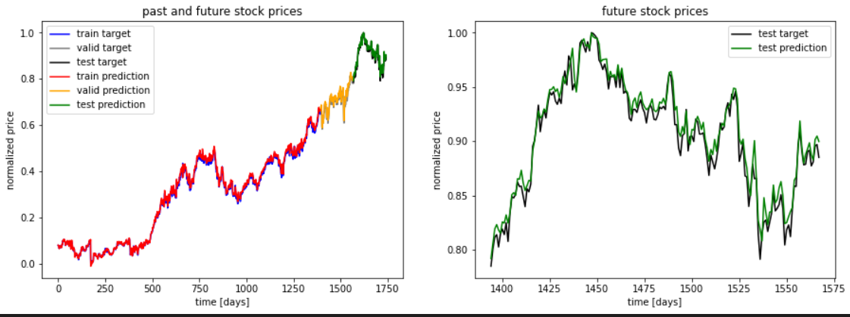

## Basic Cell RNN in tensorflow

index_in_epoch = 0;

perm_array  = np.arange(x_train.shape[0])

np.random.shuffle(perm_array)

# function to get the next batch

def get_next_batch(batch_size):

    global index_in_epoch, x_train, perm_array

    start = index_in_epoch

    index_in_epoch += batch_size

    if index_in_epoch > x_train.shape[0]:

        np.random.shuffle(perm_array) # shuffle permutation array

        start = 0 # start next epoch

        index_in_epoch = batch_size

    end = index_in_epoch

    return x_train[perm_array[start:end]], y_train[perm_array[start:end]]

# parameters

n_steps = seq_len-1

n_inputs = 4

n_neurons = 180

n_outputs = 4

n_layers = 2

dropout_rate = 0

learning_rate = 0.001

batch_size = 50

n_epochs = 100

train_set_size = x_train.shape[0]

test_set_size = x_test.shape[0]

tf.reset_default_graph()

X = tf.placeholder(tf.float32, [None, n_steps, n_inputs])

y = tf.placeholder(tf.float32, [None, n_outputs])

# use Basic RNN Cell

layers = []

for i in range(n_layers):

    layers.append(tf.contrib.rnn.DropoutWrapper(tf.contrib.rnn.BasicRNNCell(num_units=n_neurons, activation=tf.nn.elu),

                                              output_keep_prob=1-dropout_rate))

multi_layer_cell = tf.contrib.rnn.MultiRNNCell(layers)

rnn_outputs, states = tf.nn.dynamic_rnn(multi_layer_cell, X, dtype=tf.float32)

stacked_rnn_outputs = tf.reshape(rnn_outputs, [-1, n_neurons])

stacked_outputs = tf.layers.dense(stacked_rnn_outputs, n_outputs)

outputs = tf.reshape(stacked_outputs, [-1, n_steps, n_outputs])

outputs = outputs[:,n_steps-1,:] # keep only last output of sequence

loss = tf.reduce_mean(tf.square(outputs - y)) # loss function = mean squared error

optimizer = tf.train.AdamOptimizer(learning_rate=learning_rate)

training_op = optimizer.minimize(loss)

list_mse_valid_adv = []

# run graph

with tf.Session() as sess:

    sess.run(tf.global_variables_initializer())

    for iteration in range(int(n_epochs*train_set_size/batch_size)):

        x_batch, y_batch = get_next_batch(batch_size) # fetch the next training batch

        sess.run(training_op, feed_dict={X: x_batch, y: y_batch})

        if iteration % int(5*train_set_size/batch_size) == 0:

            mse_train = loss.eval(feed_dict={X: x_train, y: y_train})

            mse_valid = loss.eval(feed_dict={X: x_valid, y: y_valid})

            list_mse_valid_adv.append(mse_valid)

            print('%.2f epochs: MSE train/valid = %.6f/%.6f'%(

                iteration*batch_size/train_set_size, mse_train, mse_valid))

    y_train_pred = sess.run(outputs, feed_dict={X: x_train})

    y_valid_pred = sess.run(outputs, feed_dict={X: x_valid})

    y_test_pred = sess.run(outputs, feed_dict={X: x_test})

ft = 0 # 0 = open, 1 = close, 2 = highest, 3 = lowest

## show predictions

plt.figure(figsize=(15, 5));

plt.subplot(1,2,1);

plt.plot(np.arange(y_train.shape[0]), y_train[:,ft], color='blue', label='train target')

plt.plot(np.arange(y_train.shape[0], y_train.shape[0]+y_valid.shape[0]), y_valid[:,ft],

         color='gray', label='valid target')

plt.plot(np.arange(y_train.shape[0]+y_valid.shape[0],

                   y_train.shape[0]+y_test.shape[0]+y_test.shape[0]),

         y_test[:,ft], color='black', label='test target')

plt.plot(np.arange(y_train_pred.shape[0]),y_train_pred[:,ft], color='red',

         label='train prediction')

plt.plot(np.arange(y_train_pred.shape[0], y_train_pred.shape[0]+y_valid_pred.shape[0]),

         y_valid_pred[:,ft], color='orange', label='valid prediction')

plt.plot(np.arange(y_train_pred.shape[0]+y_valid_pred.shape[0],

                   y_train_pred.shape[0]+y_valid_pred.shape[0]+y_test_pred.shape[0]),

         y_test_pred[:,ft], color='green', label='test prediction')

plt.title('past and future stock prices')

plt.xlabel('time [days]')

plt.ylabel('normalized price')

plt.legend(loc='best');

plt.subplot(1,2,2);

plt.plot(np.arange(y_train.shape[0], y_train.shape[0]+y_test.shape[0]),

         y_test[:,ft], color='black', label='test target')

plt.plot(np.arange(y_train_pred.shape[0], y_train_pred.shape[0]+y_test_pred.shape[0]),

         y_test_pred[:,ft], color='green', label='test prediction')

plt.title('future stock prices')

plt.xlabel('time [days]')

plt.ylabel('normalized price')

plt.legend(loc='best');

corr_price_development_train = np.sum(np.equal(np.sign(y_train[:,1]-y_train[:,0]),

            np.sign(y_train_pred[:,1]-y_train_pred[:,0])).astype(int)) / y_train.shape[0]

corr_price_development_valid = np.sum(np.equal(np.sign(y_valid[:,1]-y_valid[:,0]),

            np.sign(y_valid_pred[:,1]-y_valid_pred[:,0])).astype(int)) / y_valid.shape[0]

corr_price_development_test = np.sum(np.equal(np.sign(y_test[:,1]-y_test[:,0]),

            np.sign(y_test_pred[:,1]-y_test_pred[:,0])).astype(int)) / y_test.shape[0]

print('correct sign prediction for close - open price for train/valid/test: %.2f/%.2f/%.2f'%(

    corr_price_development_train, corr_price_development_valid, corr_price_development_test))

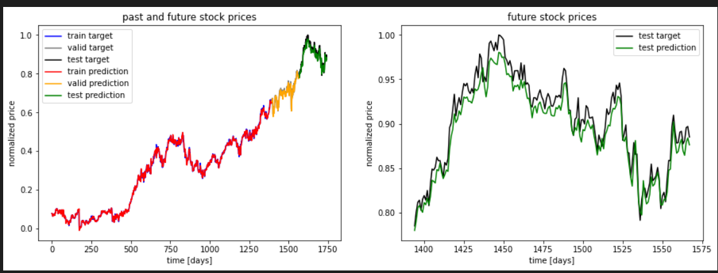

val_loss = list_mse_valid

val_loss_adv = list_mse_valid_adv

val_loss = val_loss[1:]

val_loss_adv = val_loss_adv[1:]

epochs_range = range(20)

plt.figure(figsize=(10,10))

plt.plot(epochs_range, val_loss, label='Втрати на валідації базової моделі')

plt.plot(epochs_range, val_loss_adv, label='Втрати на валідації покращеної моделі')

plt.legend(loc='lower right')

plt.title(f'Графіки втрат покращеної моделі')

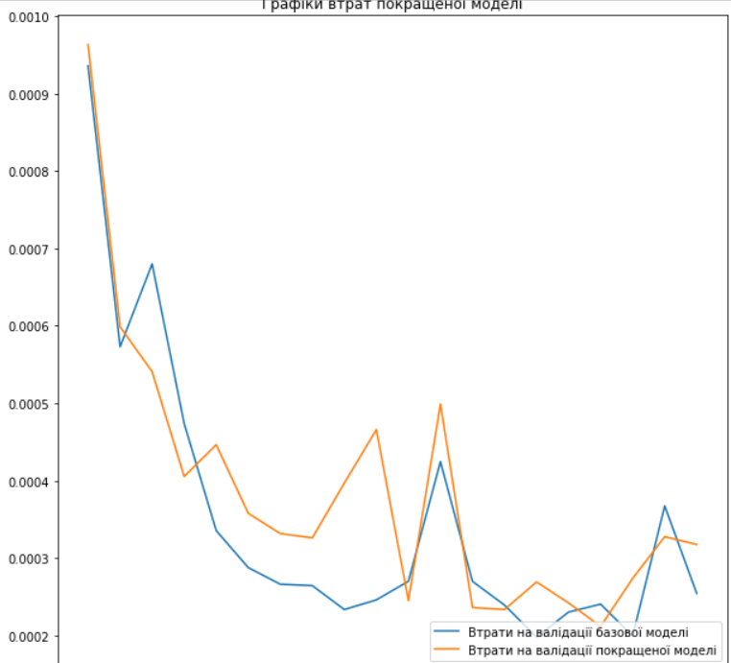

**Висновок:** На даній лабораторній роботі, виконав поставлені завдання а саме Вивчити структуру LSTM та GRU та принцип побудови мережі, розібрався з Case1 – прогнозування сигналів, розібрав з задачею прогнозування часових рядів, досягнув кращої точності ніж наведено в прикладі.